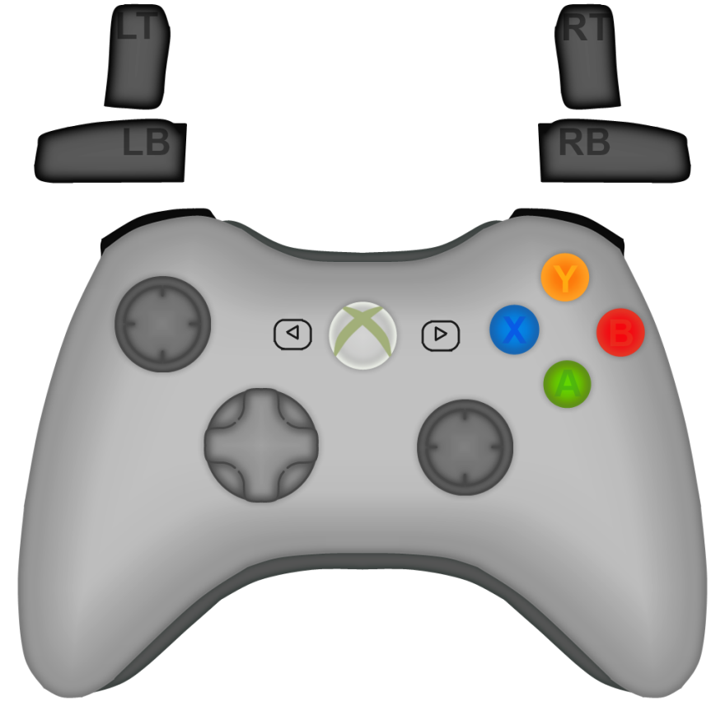

|  |  |  |  |
| --- | --- | --- | --- |
| Driving Controls 2014 (As Zach has been given, please revise) | | | |
| Movement | | Mechanics | |
| Left Joystick | Forward/Backward | Left Joystick |  |
| A |  | A | Low Possession |
| B |  | B | High Possession |
| Y |  | Y | High Open |
| X |  | X |  |
| Right Joystick | Turn Left/Right | Right Joystick |  |
| Left Bumper | High Gear | Left Bumper | Truss Shoot |
| Left Trigger |  | Left Trigger | Expel Roller |
| Right Bumper | Low Gear | Right Bumper | Goal Shoot |
| Right Trigger |  | Right Trigger | Intake Roller |
| D-Pad |  | D-Pad |  |
| Start (|>) |  | Start (|>) |  |
| Back (<|) |  | Back (<|) |  |
| X-Box Button |  | X-Box Button |  |